Skelbrooke Scale Competition
12/09/2021
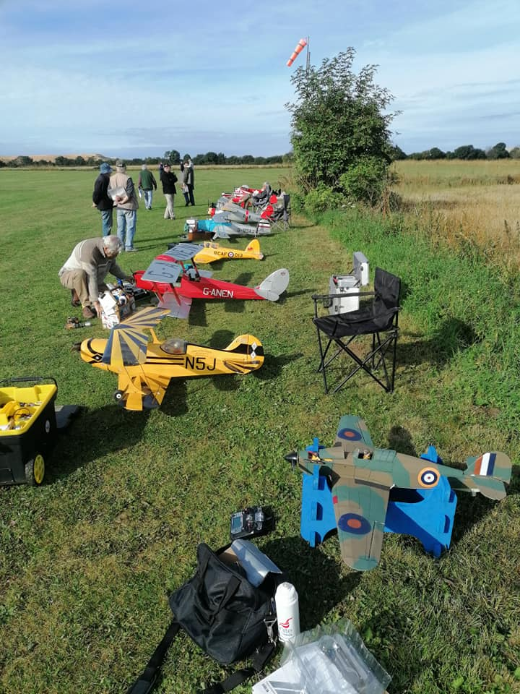
Hello all! It’s been a while, but I’ve finally found time to sit down and type up a little ditty about my grand day out with the BMFA Scale Competition department at Skelbrooke in early September (Further delays added by Mark ‘web master’ Youatt….. sorry Ian!). Scale flying has been something I’ve wanted to try since I realised how much fun toy aeroplanes are, especially when they look like a real one. So armed with my trusty Vintage Model Company Hurricane (1/12 scale, 44” wingspan, waiting for the scramble bell in the foreground of the picture to the right) I made the hour drive down to Doncaster(ish).
Fortunately, having found a few references of the Skelbrooke Model Flying Club on Google, navigating to a field in the middle-of-nowhere was actually very easy, once I’d put the lat/long details in to the satnav. The site itself is slightly peculiar, in that instead of being at the edge of a field as you’d usually expect, it’s up a track through a field, and is situated in the centre of a large flat farmer’s field. The actual flying site is roughly square, covering approximately the same area as WHMFC, but due to it’s odd location, there are no difficult approach directions due to being clear all round. The strip itself is well kept, but some models did struggle with an unexpected bounce from the remains of old ploughed furrows left over from the ground’s previous life. The weather conditions were near perfect, with some overcast cloud cover later in the day just making my Battle of Britain colour scheme a little too silhouetted for comfortable orientation.
As my first scale competition, I wasn’t entirely certain what to expect. Being a “flying only” event, there was obviously no static judging, but scale models are, of course, compulsory. That being said, without any kind of “builder of the model” rule in flying only classes, ARTFs and foamies are perfectly acceptable, and it was around a 50/50 split between built and assembled aircraft. As a newcomer, I was placed well down the running order, so that I had a chance to watch and learn the general “etiquette” of how the flying order runs. I soon “buddied up” with another flyer, in order to act as each others caller for the routines that we’d be flying and help each other set up our models and start engines (that latter part being much more applicable to his ¼ scale Tigermoth than my borderline park flyer!). The day was split in to two rounds of flying, one either side of lunch, with the day starting at 1000 and finishing around 1600.
Round 1
The first thing to note, is that the competition starts right from the beginning. There is no chance for a warm up! My buddy was a few flyers up the order from me, so my first direct involvement of the day, was restraining for starting the biggest model I’d ever touched, helping to carry it out of the pits, and trying to call manoeuvres for its pilot in such a way that gave him the information he needed, without putting him off his flight. This was quite possibly the most nervous I’ve ever been at an RC airfield, including that first solo flight eighteen months ago. As it came to my turn to fly, the nerves only got worse. My hand launch was shocking, all of my manoeuvres felt sloppy, and as always, my first ever landing approach at a “new to me” field was wildly off. When the first-round scores were posted over the lunch break, I’ll be honest and say I was a little disappointed to be 265 points behind the others in the “Light Scale Class” (sub 3kg), with a score of 532.5. But the other pilots were quick to point out that take off and landing are worth 150 points each, and I was scoring zero for each due to hand launching and belly landing, so my flying score really wasn’t that far behind the rest of the guys in my class.
Round 2
After lunch, I was much more settled in. I was able to give my buddy some slight pointers on his positioning when I was calling for him, and my flight was much more controlled, a lot smoother, and earned me a slight improvement on points up to 546.5 and I felt much happier with my performance, despite the gathering cloud making orientation incredibly difficult.
Summary
I thoroughly enjoyed my day out, having a fly and meeting new people. That being said, there are some down sides to scale competition flying. It’s a long drive, and a long day sat in a field for two flights, that may or may not be your best performances due to nerves, or flying at an unfamiliar location, so I fully understand it may not be for everyone: I certainly wouldn’t want to do that every weekend. But there a lot of good points. The models are beautiful. These guys take making them look good very seriously. Having a judge score your flying really makes you think through every manoeuvre, and is a great way of improving your flying. You can make it as hard or as easy as you like. It’s not about the most nail-biting aerobatics, it’s about flying the model you’ve got in the way it should be flown. A bomber, or a civilian general aviation craft would be flying a much gentler routine than a jet fighter, and you choose your own manoeuvres to suit. I’ll put a list of the possible options as an appendix, and you can all see for yourselves.

Ian Payne

