Achievement Scheme Training and Testing Day,
At Fenland Model Flying Club, 25/09/2021

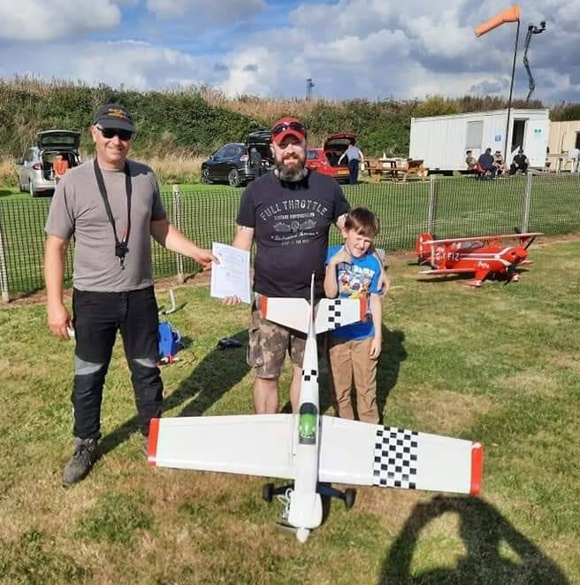
I guess I’ll start with, “I DID IT! I PASSED MY “B” CERTIFICATE!!”. Now that’s out of the way, I suppose I should tell you all more about it.
Having passed my “A” test on my Junior 60 at Beverly last year, I was aiming to get my “B”, or at least, close to it, this year. Having destroyed my first four channel aeroplane through a basic building mistake, and then destroying my first low wing aircraft through an adjustment error, the Saito 72 powered Acrowot flew off the build board a little tentatively, but soon proved itself to be the one that would progress my flying more than all the others. And so, nine months, three crashes and two major rebuilds, my flying was at the point where a good day flying would give me the confidence to seriously consider booking a test, but the ensuing two or three week break from flying, would have me almost back to square one, and relearning all the aerobatics from scratch again. So, I decided to book myself on one of the training and testing days run by the Achievement Scheme Committee. There have been some in Doncaster, but the only one available to book at the time, was at Fenland Model Flying Club, near Spalding in Lincolnshire.
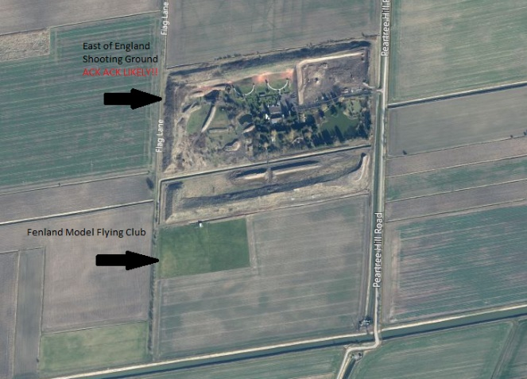
Nearly a three-hour drive away, I decided to make a weekend of it, and so booked camping at Ashleigh Lakes Camp Site in Whaplode Drove, about ten minutes’ drive from the airfield. The campsite, whilst basic and a little tatty, was kept perfectly clean, with friendly staff and access to some fishing lakes. If you’re in to that kind of thing, I highly recommend a stop off here on your travels. The flying club and site are both excellent. A very jovial atmosphere with excellent facilities: on sight toilet, BBQ, expansive flight line and a fully mown field. The only two drawbacks being the northern No Fly Zone, where the flying club boarders the East of England Shooting Ground. That No Fly Zone is enforced with clay pigeon and buckshot! The other drawback to the club, is that it sits right on the edge of the FRZ for a local general aviation field. They do have a fantastic collection of aircraft, including some warbirds, which you get a great view of their base leg approach, but having to stop aerobating whilst you’re in the zone, as a stream of 1/1 scale planes go over is very frustrating. That being said, between the Club, the fishing, the shooting, the full-size aviation, I am fully intending to make another stop there next year! Apparently, the clubs warbird weekends are fantastic.

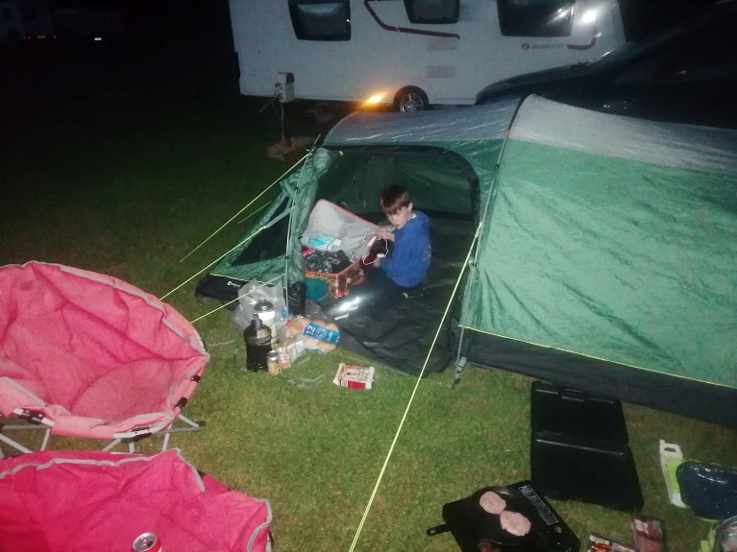
Flying on the day started at 1000, after a brief at 0930. There were a few club members in attendance, as well as the examiners and trainees, but all were clearly instructed that those visiting for tests and training had priority for the day, which was most generously adhered to all day. The flying was kicked off by an Area Chief Examiner demonstrating the finer points of a “B” flying schedule. At which point I had a minor panic: none of my stall turns had ever looked like that! But I was soon put at ease by the examiner who had volunteered to be my coach for the day, “there is leeway in the marking” he assured me.

So, I took my first flight, nothing exciting aerobatically, just trying to get settled in. I slowly built up to flying the full routine over three or four flights, every time with an examiner giving me hints and tips, until I stopped for some lunch.

One issue I’d had all morning was with those stall turns I mentioned earlier. Apparently, every stall turn I’ve ever done has really been a wing over. So, I took two flights after lunch to attack stall turns, nonstop, with some very disheartening results. Now, this is where the encouragement of the examiners comes in. At this point on a normal flying day at Willy Howe, I’d have packed up, thinking I was pushing my luck and preferring to take everything home in one piece and not chance it. Well, they didn’t let me. I took it back out for another “practice” flight, and told my instructor that I’d do the full routine, until I got stuck, then practice the problem manoeuvre.

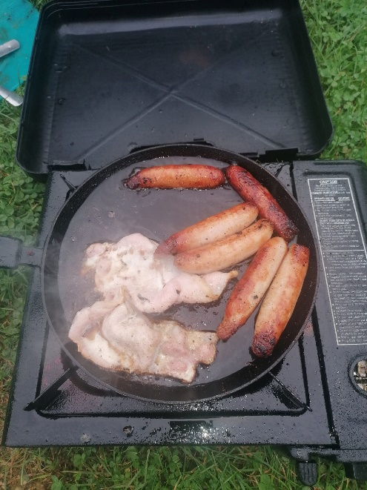
Take off was fine. Figure of eight was perfect. Inside loop needed an adjustment whilst inverted, but it was good enough. Outside loop was perfect. Both sets of aileron rolls weren’t perfect, but showed a good level of control. Then I nailed an absolutely perfect stall turn for the first time ever! The spin was perfect (I love spins), and the aborted landing, reverse circuit and landing were all text book. I collected my aircraft after waiting for another pilot to land, and prepared to refuel for an “official attempt” at the test. Unbeknownst to me, whilst I was taking off, a second examiner had sidled up behind me, and turned it in to an official test. I passed without even knowing it! And having passed my Registration Competency Test, I was exempt the mandatory questions. A short question and answers sessions, more like a friendly chat, sealed the deal on my certificate. What better way to celebrate than fried food on a camping stove?
Hoping for a Scale C Certificate next year.

